

SKR & SKR Govt. College for Women (A), Kadapa has well established Women Empowerment Cell. The faculty conduct programmes on gender sensitization and gender equality by inviting the eminent personalities from organisations to empower girl students to realize their potentialities and power in socio economic and political spheres of life. The cell encourages the girls to talk about women issues and tries to sensitize the youth about gender reality. WEC prepares strategic action plan with objectives to build capacities and capabilities to solve the problems.

The Women Empowerment and Protection Cell takes care of the safety and security of women. It protects the rights of women and looks after their amenities and their maintenance. It conducts various gender sensitive campaigns, seminars and workshops. Girl students are deputed to attend women conferences and parliaments and participates various gemder sensitization activities conducted in the college by Women Empowerment, NCC,NSS organizations.

Objectives:

- To empower women students by organising guest lectures, seminars, workshops, awareness programmes.

- To make them mentally strong, and to develop problem solving capacity awareness programmes on women rights are conducted by Legal services Authority, Kadapa.

- To ensure physical fitness among women students, self defense courses and health awareness programmes organised.

- To develop cordial relationship between teacher and taught, Mentor-Mentee system is implemented.

- To organize Stress Management, Yoga, Meditation sessions for stress free environment.

The college celebrates women’s Day every year by conducting various competitions, organizing rallies and motivational lectures.
- The Women Empowerment and Protection Cell takes care of the safety and security of women. It protects the rights of women and looks after their amenities and their maintenance. It conducts various gender sensitive campaigns, seminars and workshops.
- Girl students are deputed to attend women conferences and parliaments.

Workshop on “Women Self Defense”
A Women Self-defense workshop was organized for the women students by the Women Empowerment Cell of SKR & SKR Govt. College for Women, Kadapa. Dr.V.Saleem Basha,,Principal of the college inaugurated the workshop and delivered opening remarks of the workshop. The workshop was organized to boost the self-confidence among the girl students and to make them able to act in unfavorable conditions. The women students were taught simple ways of self-defense.
The students also spoken about to tackling situations in which they found themselves to be under any kind of harassment. The safety of the women students should be given maximum priority and hence the workshop was seen as a boon to the women who often have to travel away from their homes for studies and work.
AWARENESS SESSION ON GENDER SENSITIZATION
In connection with World Literacy Day, the Women Empowerment Cell of the college organized a meeting on “Gender Sensitization” on 08-09-2023 in the auditorium of the college. Dr.V.Saleem Basha, the Principal and Chief guest of the awareness session spoke aboutgender, gender equality and inequality, problems of gender inequality, major reasons for gender discrimination, sexual harassment at workplace, sexual harassment prevention training etc.and advised the students don’t encourage this type of discrimination in their families.
ROLE OF THE WOMEN IN THE FAMILY AND THE SOCIETY
The most important goal of education in the context of women’s development is for inculcation the values of gender equality and gender justice, for removing the discriminatory attitudes and practices against women. The only way in which a modern society changes and develops is through education. Napoleon once said, “Give me good mothers and I will give you a good nation”. A woman’s hand in changing the nation from preliterate to literate is substantial. Education is widely important in raising the living standards of the population and the status of girls. It also contributes to improving productivity and reducing population growth rates. The mother is solely responsible for her children’s education and is often the pivotal force in making them stay in school.

Awareness program on “Disha App & cyber security”.

Sri Nagaraju, CI, Kadapa Station and his associates of Police Department enlightened the students on Disha app. He explained about the installation and usage of the app.

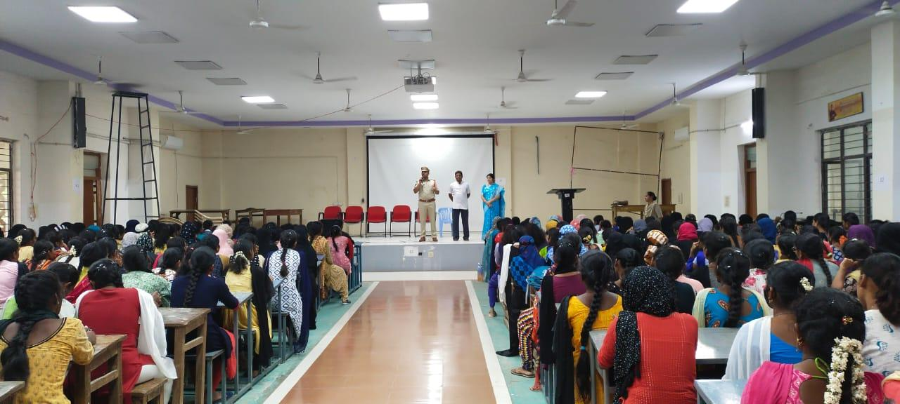

Name of the Activity: “Awareness Program on Disha App”
Date : 29-09-2023
Resource persons: Smt. Lakshmi, S.I., Sri.Murali Mohan, S.I, Sakhi admin Smt.Aswini& STEP Manager Sri. V.V. Subbarayudu
Summary of the activity: Police officials explained the importance, installation & usage of Disha app in the mobile phones to the students. Students have downloaded and installed the app in their mobile phones.
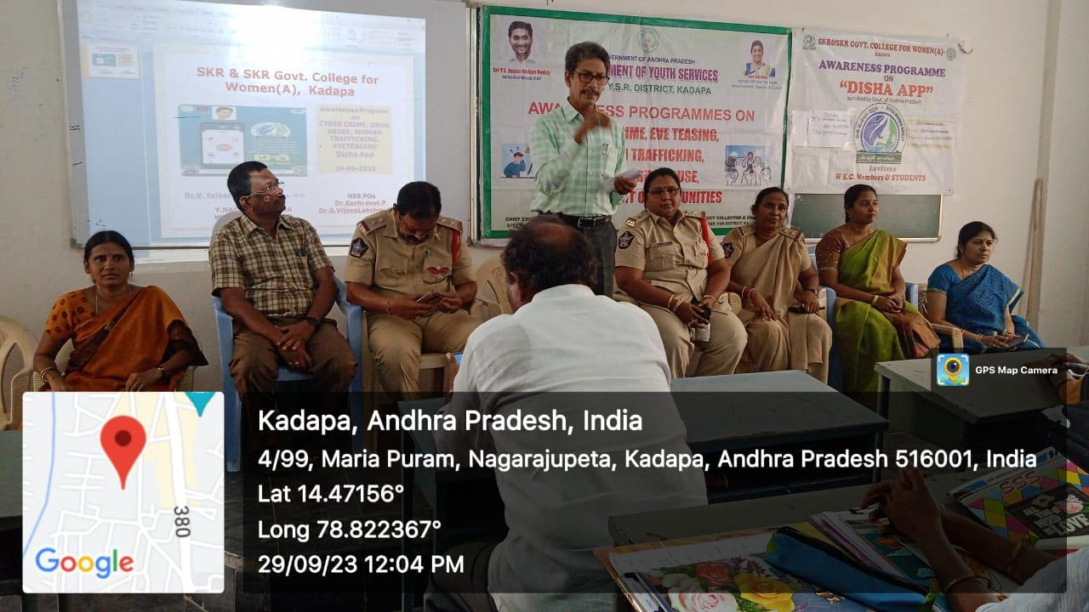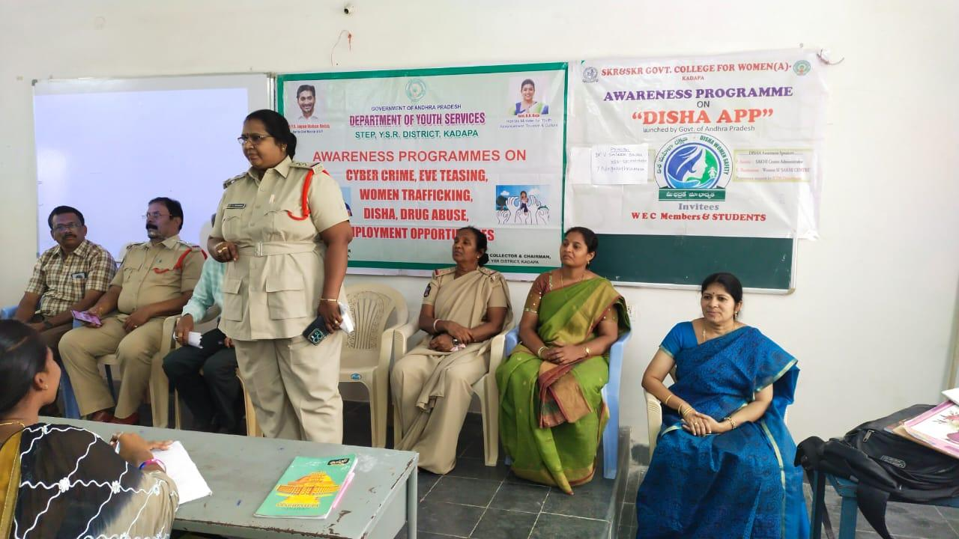

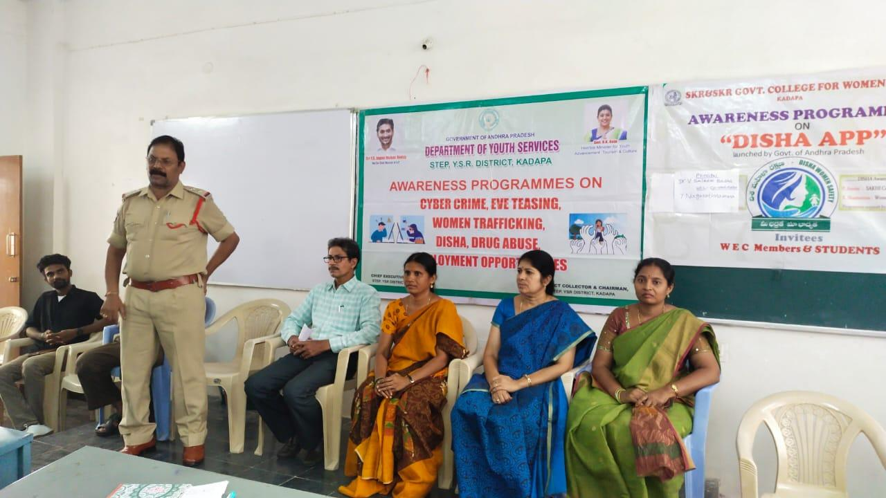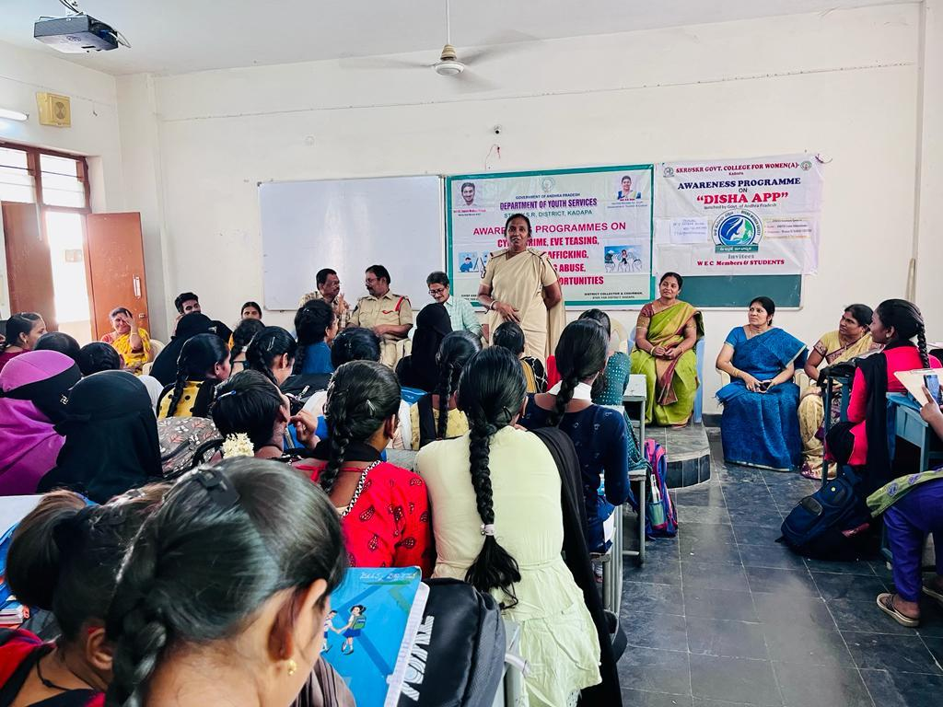
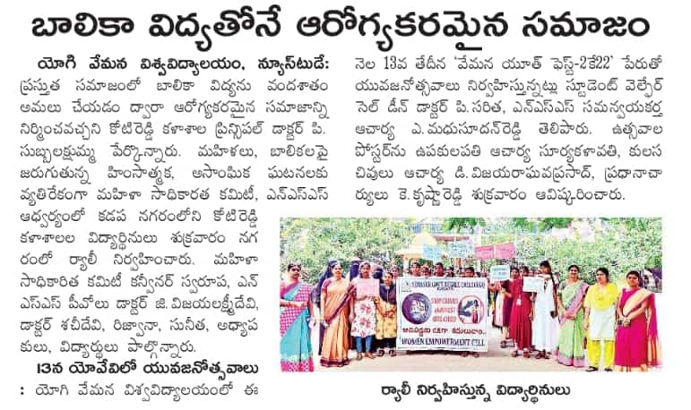
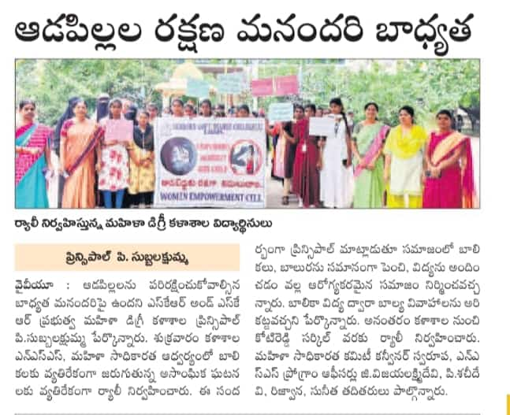
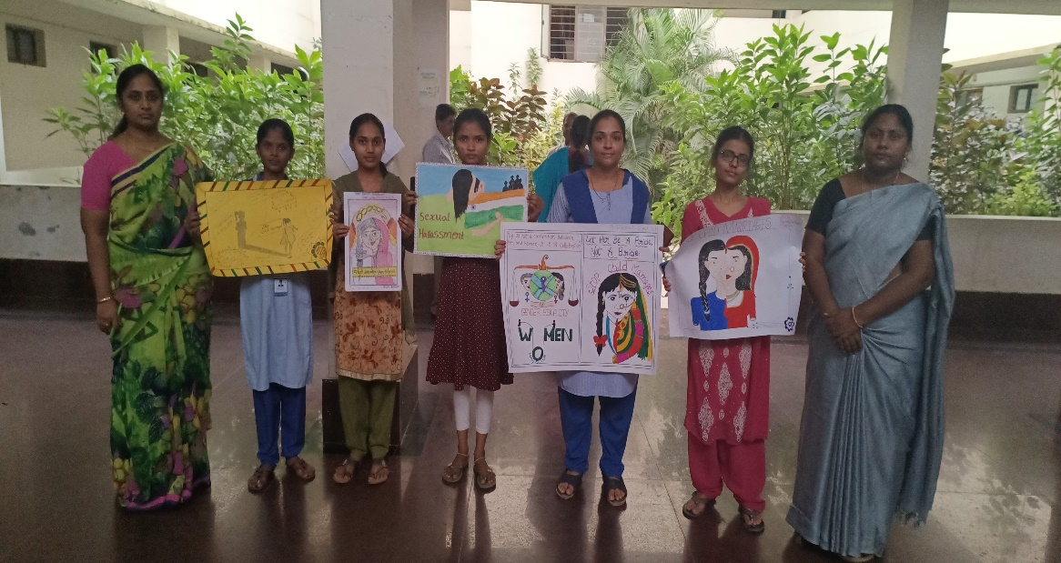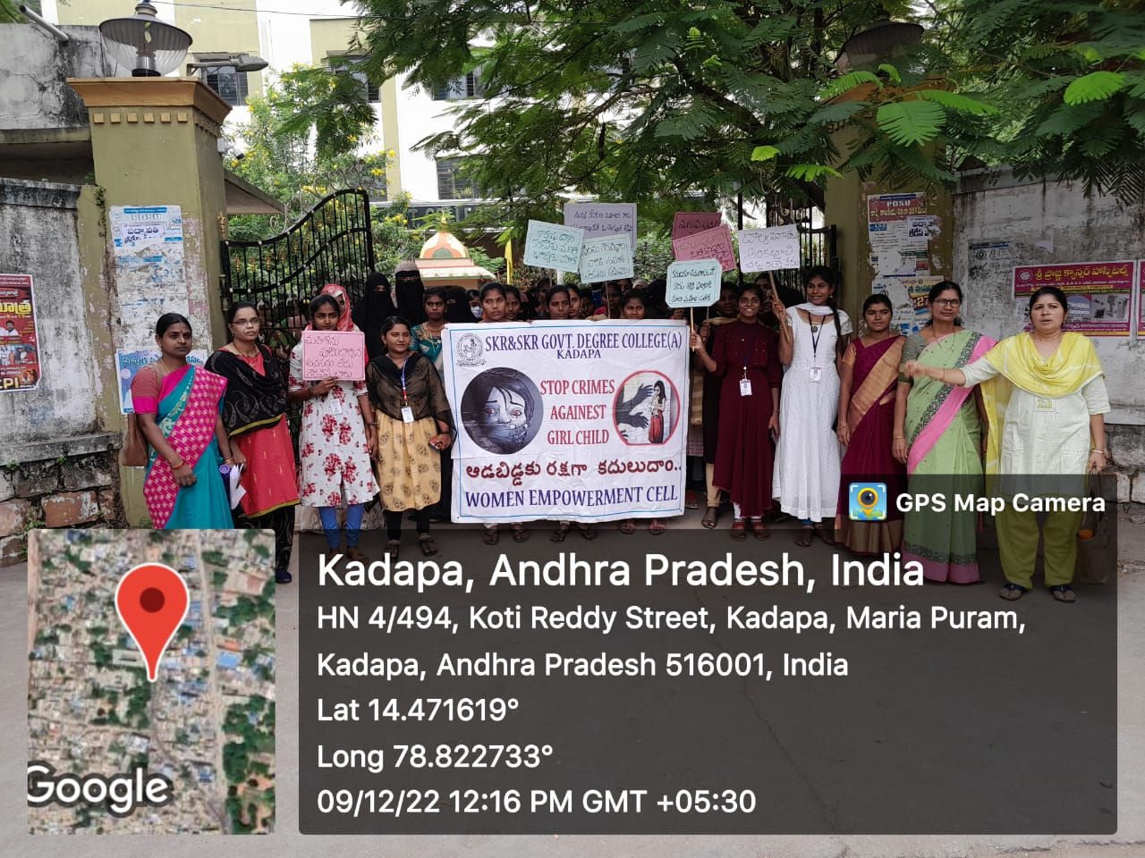
GENDER EQUITY PROGRAMMES TO THE GIRL STUDENTS BY WOMEN EMPOWERMENT CELL

RALLY CONDUCTED TO AWARE SOCIETY ABOUT CHILD MARRAIAGES AND
THEIR ADVERSE EFFECTS
On 3-12-2023
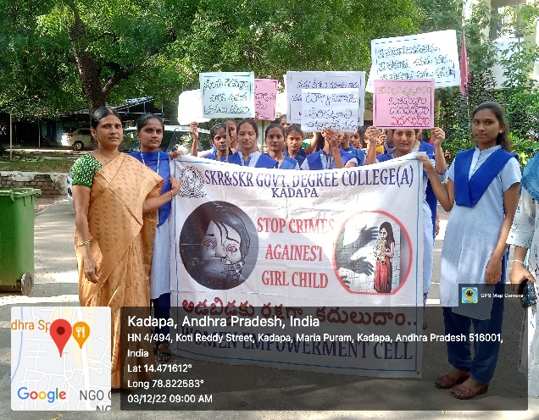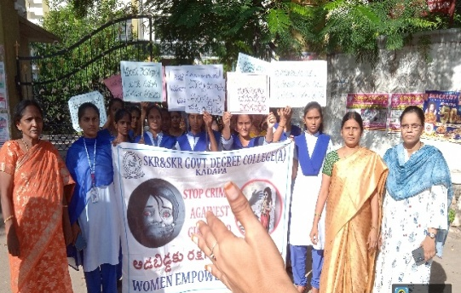
ELOCUTION COMPETITION ON CHILD MARRIAGES ON 3-12-2023
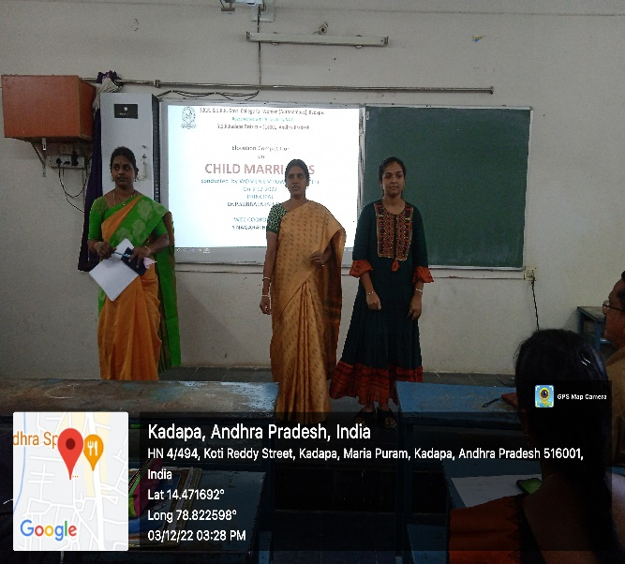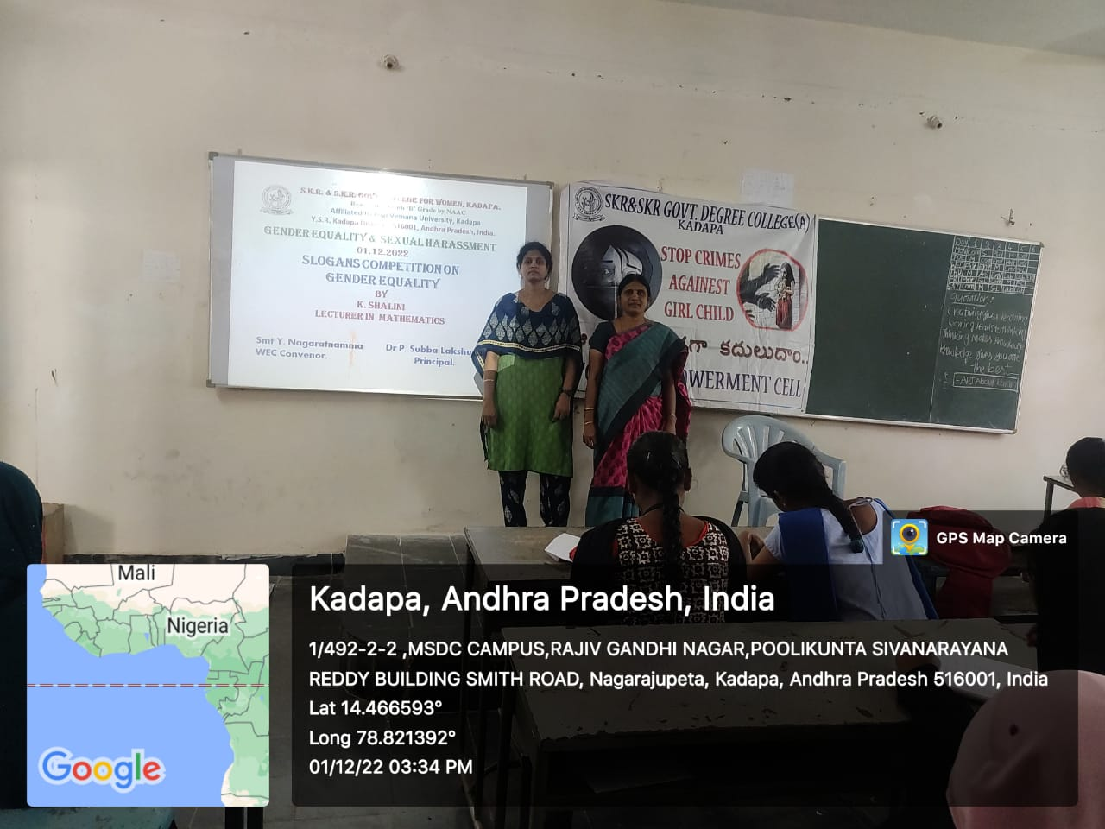

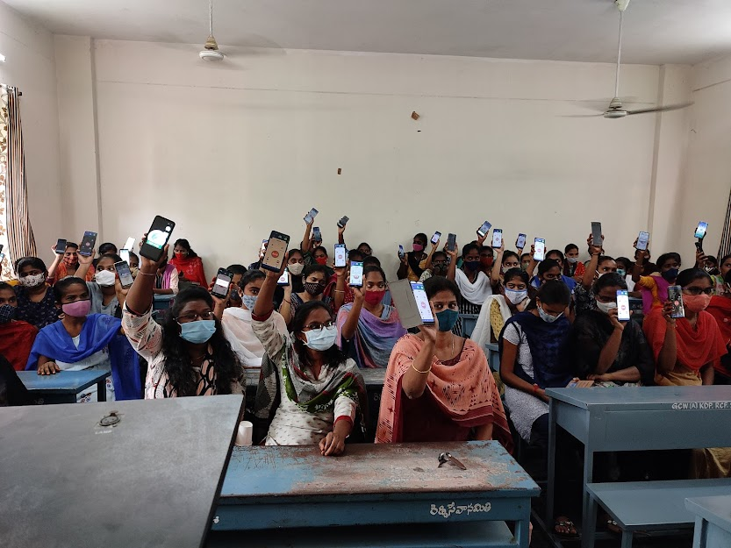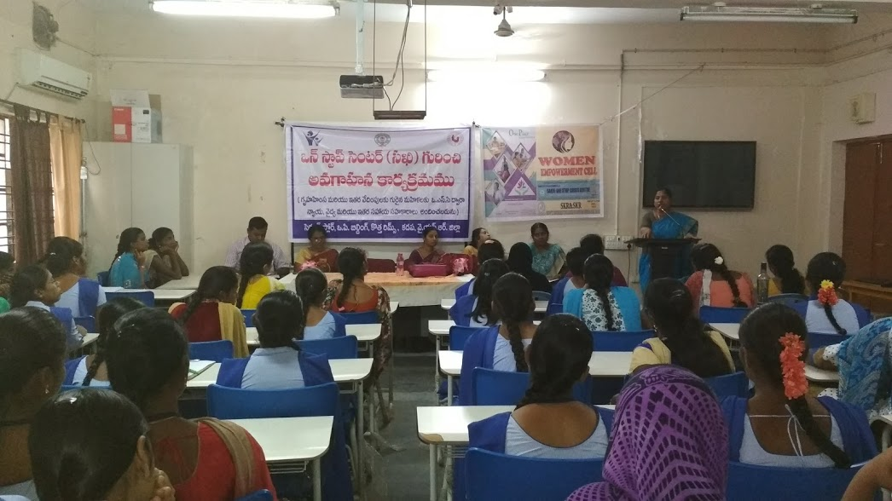
Redressal committee organised awareness programme on Disha app

Invited talk on “Insight into pathway Courses by Dr.G.L.N.Prasad
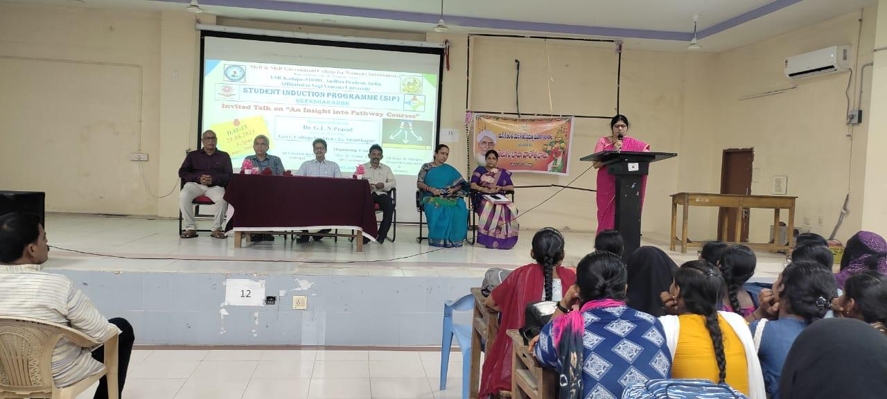
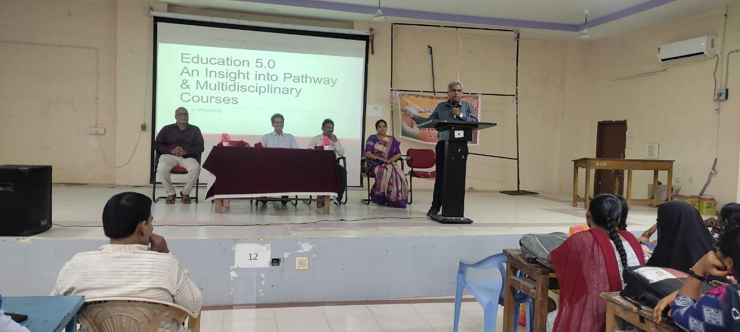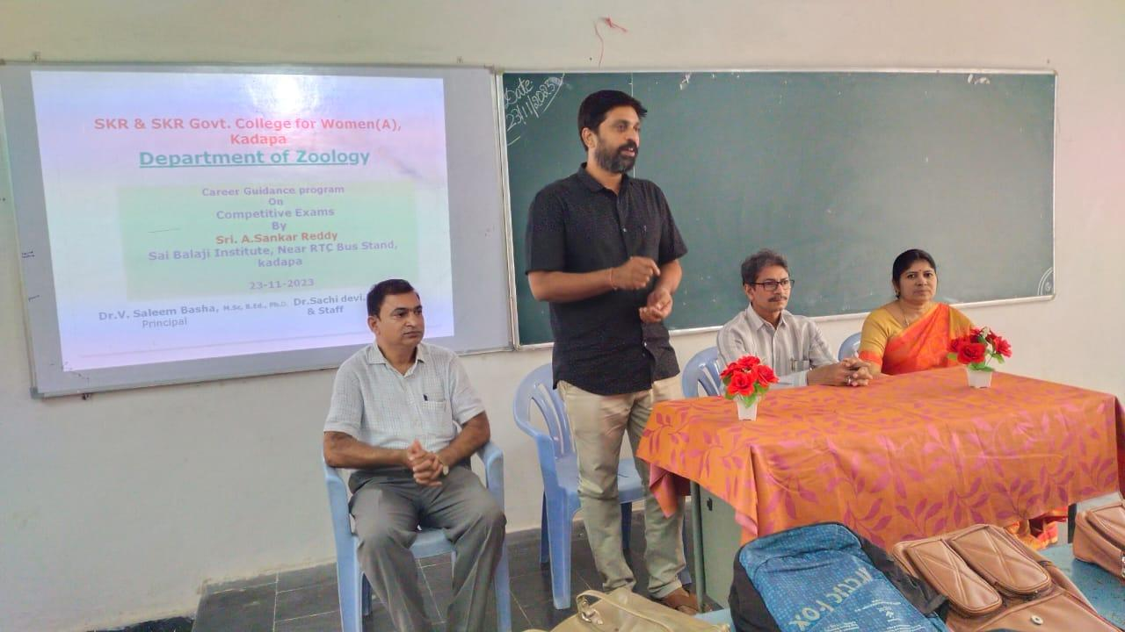

Carrer counseling by Vijaya Lakshmi Superintendent of Customs and Central Tax, Nellore
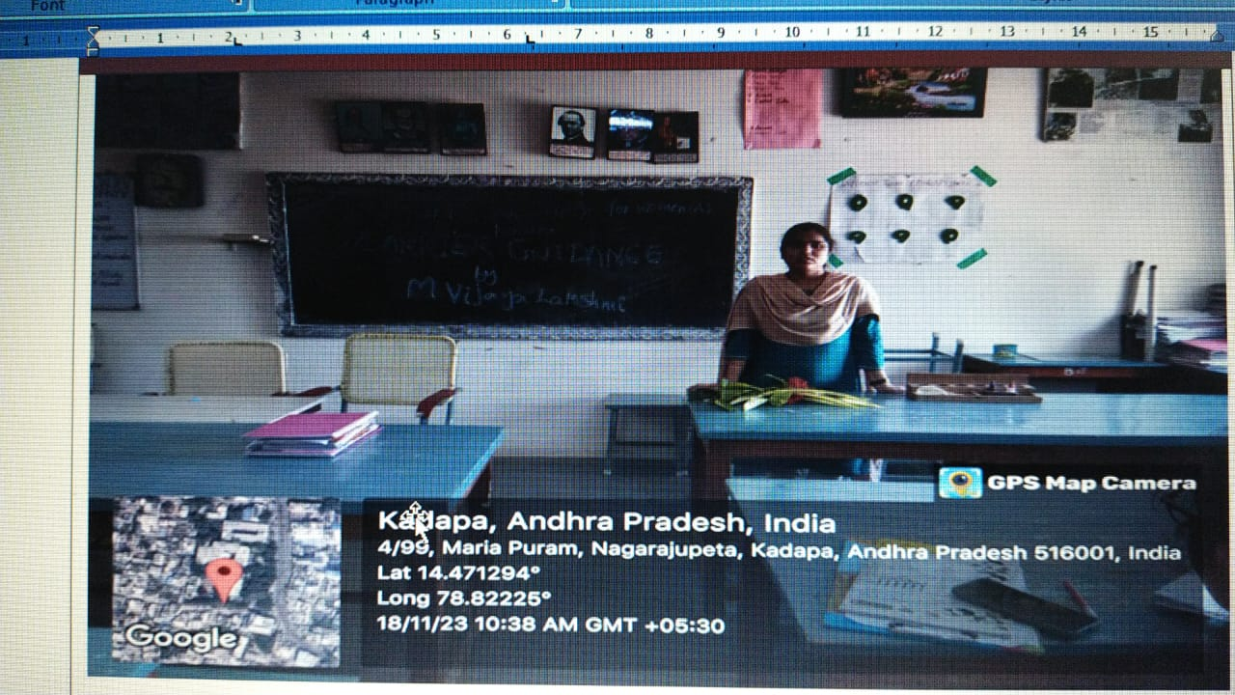

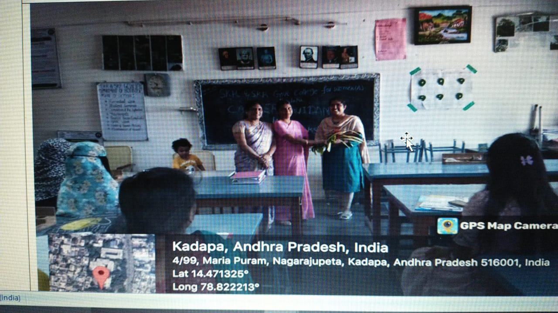

Students’ placements in Radio station, Kadapa as Yuvavani Assignees.
K.Saidivya Vani, III BtZC
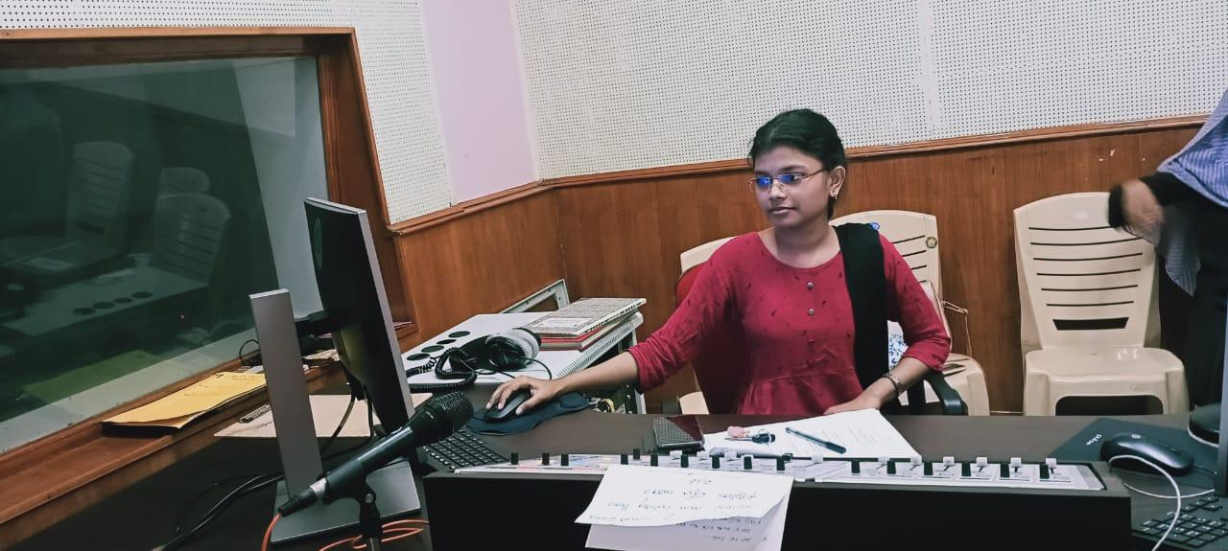
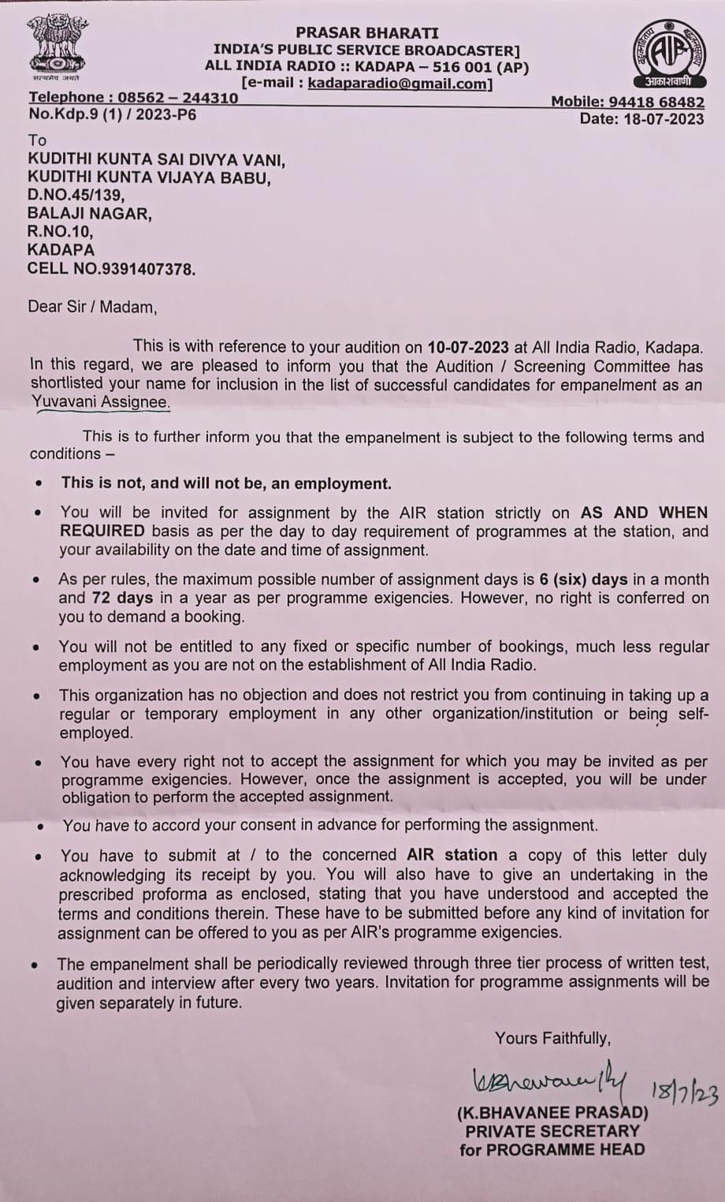

B.Thanmai, III BZC
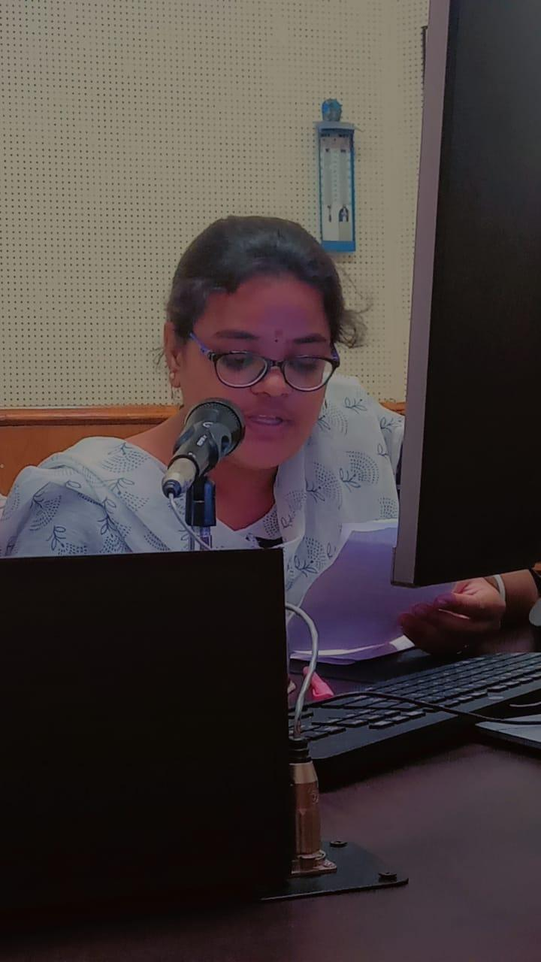
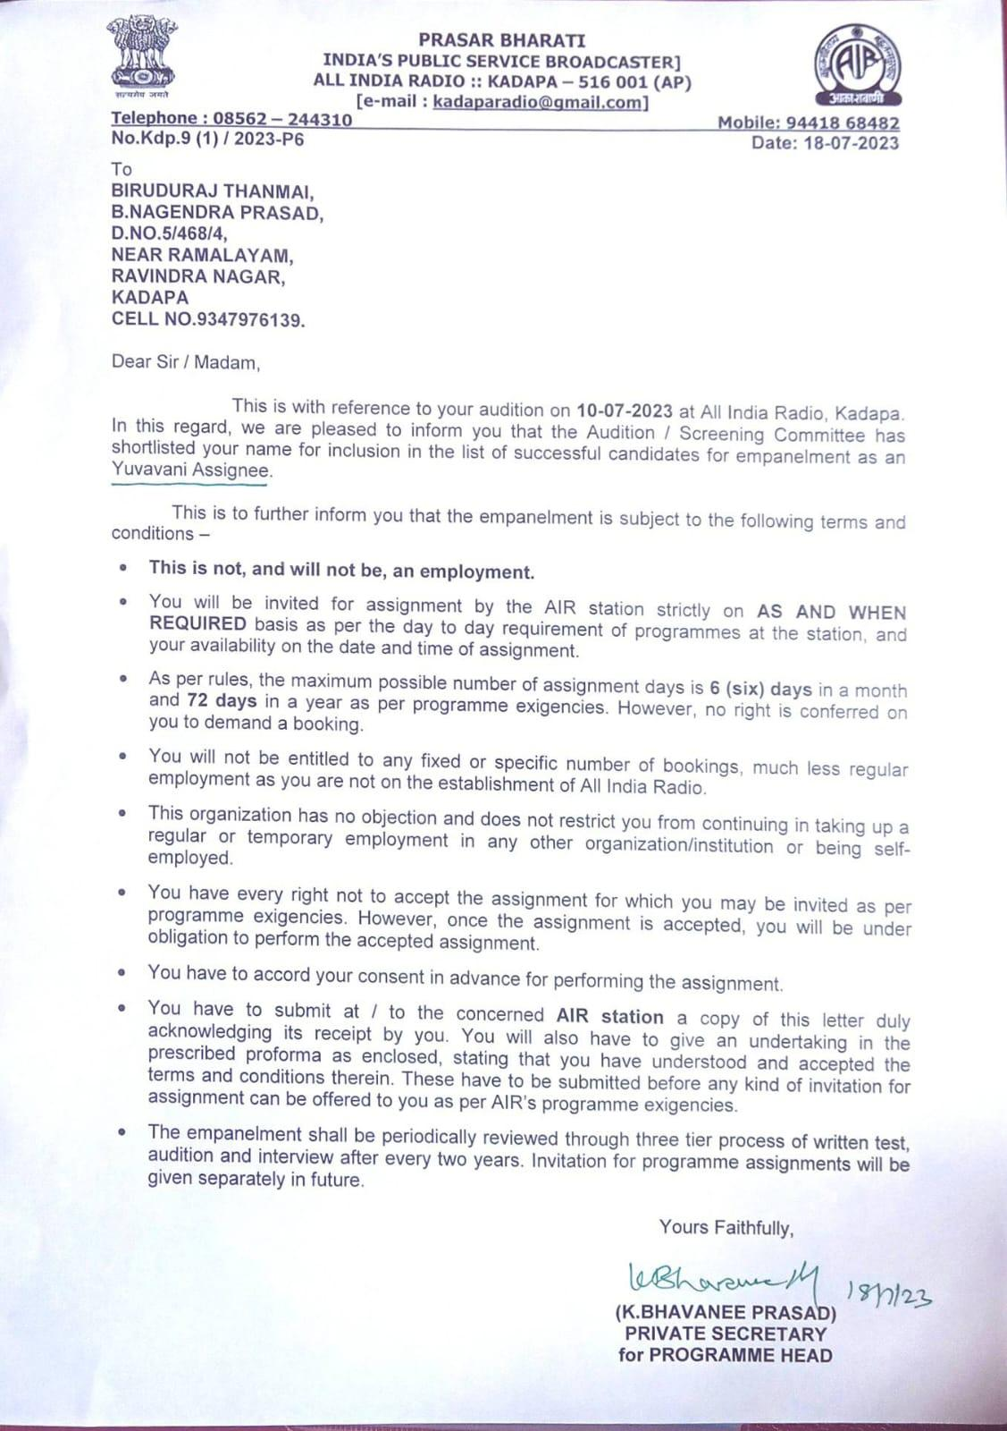

Shaik Afreen-II BZC
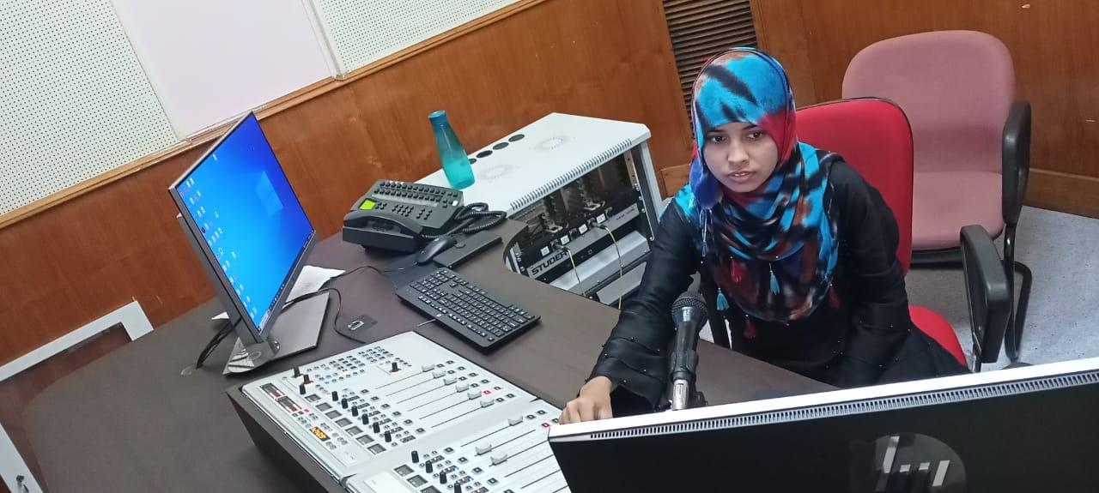
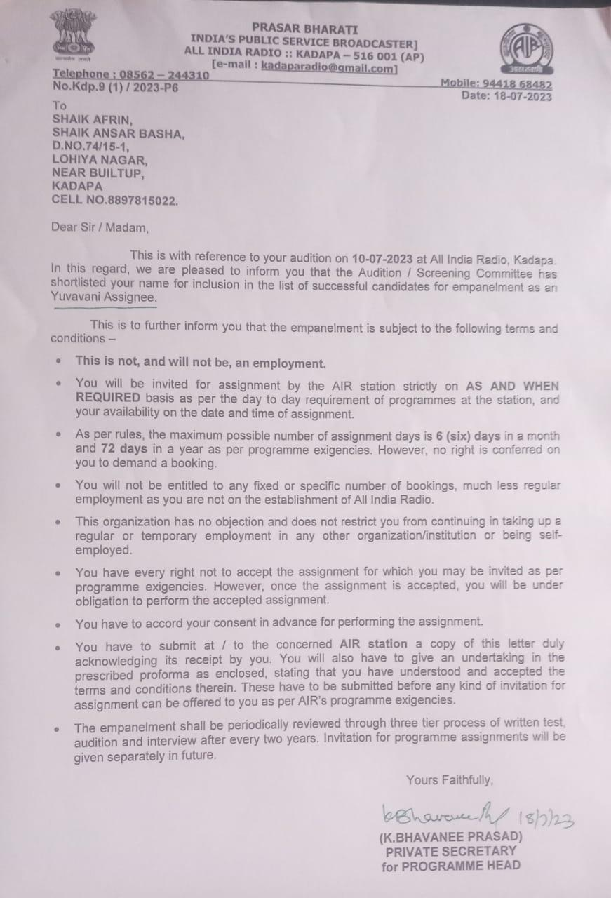

Awareness program on HIV/ AIDS eradication,
Women Health & Hygiene

Name of the Activity:
“Awareness program on HIV/AIDS - women Health and Hygiene”.
Date: 28-11-2023
Names of the Lecturers involved: Dr. P.Sachi Devi, Lecturer in Zoology
Mrs. R. Vahida, Dr. Meena Kumari & Mrs. M.N. Rizwana.
Resource person:Dr.Palla Tejaswini, Gynaecologist, Palla Hospital, Kadapa.
Summary of the activity: Department of Zoology in association with NSS & Red Ribbon Club organised Awareness program on HIV/AIDS-women Health and Hygiene. Dr.Palla Tejaswini, Gynaecologist, Palla Hospital, Kadapa attended the program as Resource Person. She enlightened the students about the causes and prevention of AIDS. As a gynaecologist she also gave medical counselling to the students on women health & hygiene.
Students participated: M.Sc., II Bt.ZC., BZC EM & I Zoology major students.
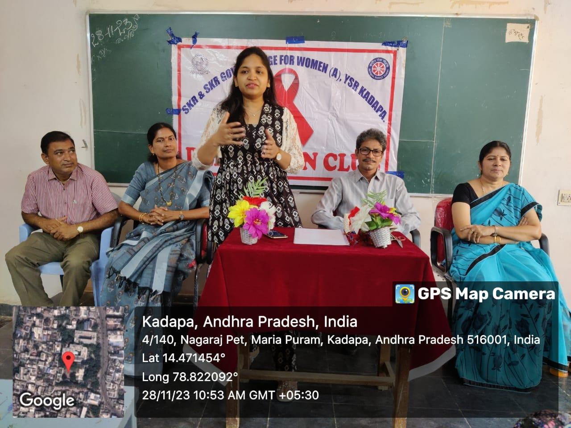
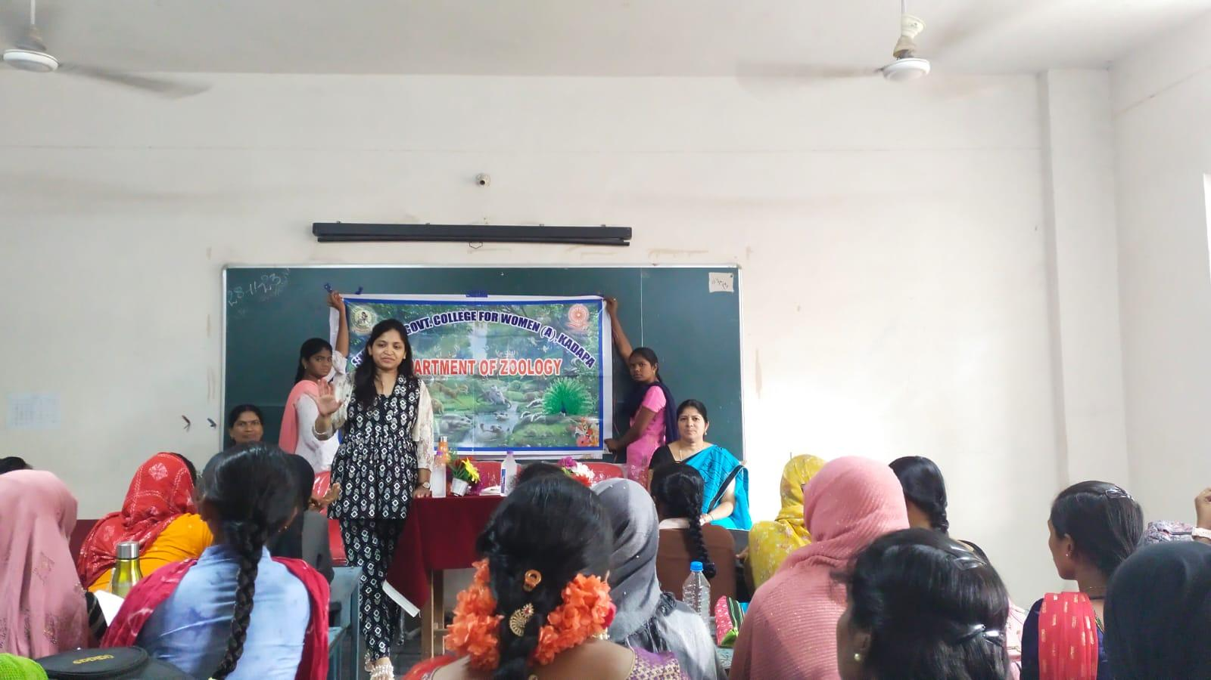
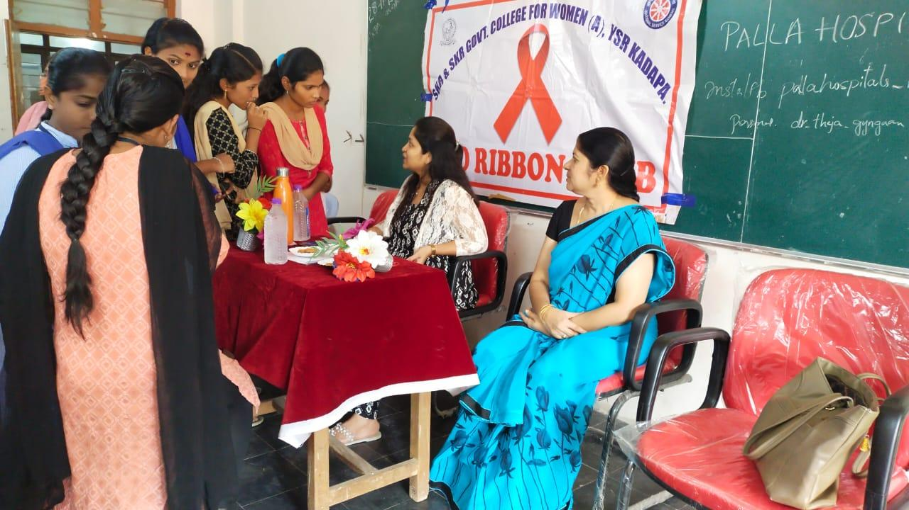
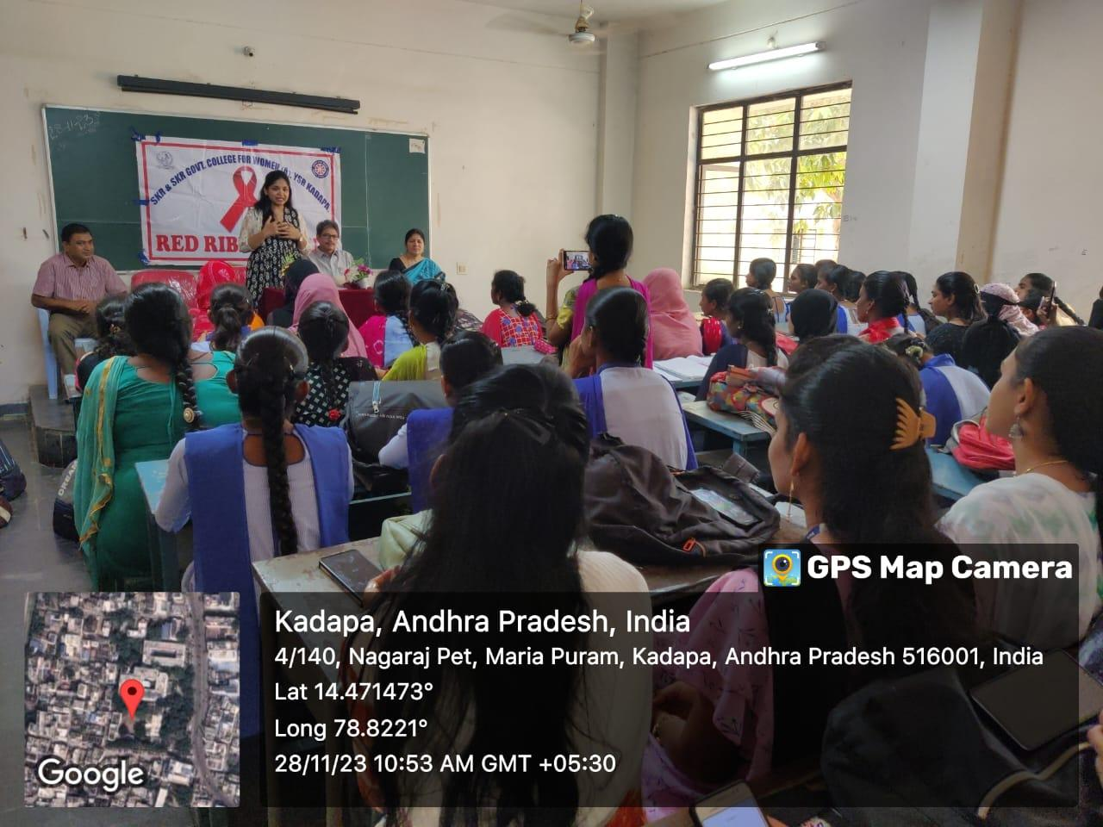
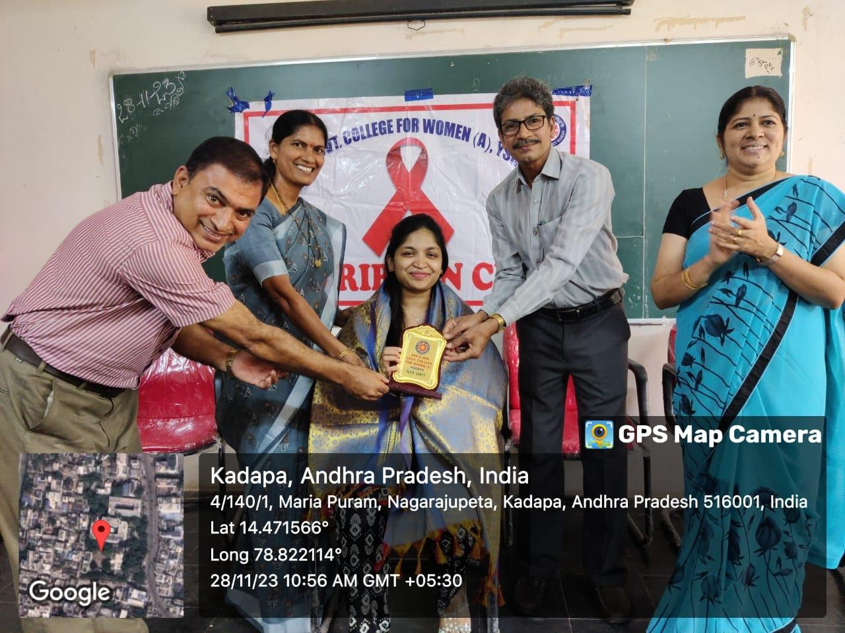
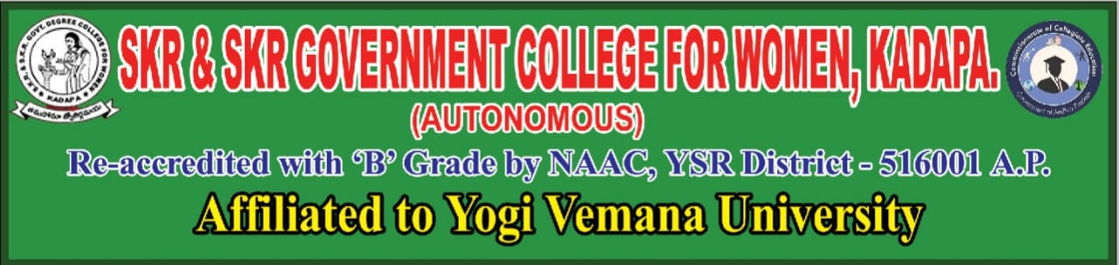
Certificate Course in Women Entrepreneurship
01.03.2024 to 06.04.2024
Women entrepreneurship refers to the practice of women starting and running their own businesses. Women entrepreneurs play a crucial role in the economy by creating jobs, driving innovation, and contributing to economic growth. In recent years, there has been a growing focus on supporting and empowering women entrepreneurs through access to resources, networks, and mentorship opportunities. Initiatives such as women-focused funding programs, business incubators, and networking events have helped to level the playing field and encourage more women to pursue entrepreneurship.
playing field and encourage more women to pursue entrepreneurship.
